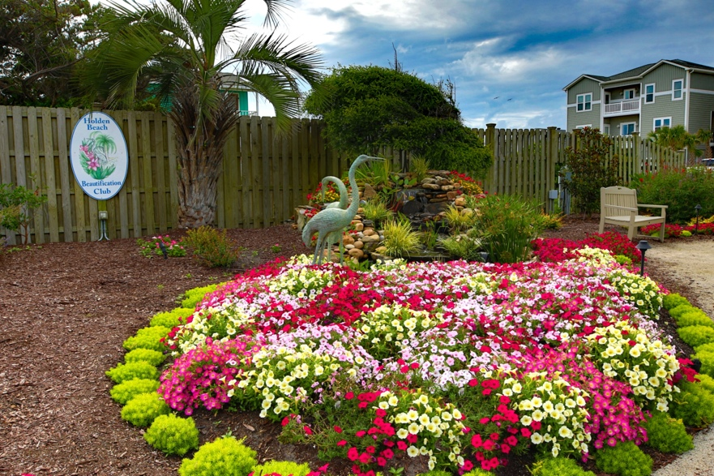
Padgett Garden – One of the Island’s gardens designed and planted by the Holden Beach Beautification Club
Holden Beach Beautification Club
2026 Sponsor Form
PROFITS ARE USED IN OUR MISSION TO MAINTAIN THE PUBLIC GARDENS ON HOLDEN BEACH
Sponsorship Benefits:
- Company Name and Logo on HBBC website January 1- December 31, 2026.
- Includes a link from our website to your website or Facebook page!
- Advertisement at our meetings and events listing our sponsors!
- A feature on our Social Media accounts annually.
Sponsorships for 2026 are $100
Name of Business: _________________________________________________
Business Mailing: __________________________________________________
Contact Person: ___________________________________________________
Phone: _______________________ Email:______________________________
Website: ________________________________________________________
Please use a link to our Facebook page instead of a website
Signature: _____________________________ Date: ______________________
- Make Checks Payable to HBBC – any amount over $100 will be considered a donation.
- Mail this form and your check to Vicki Myers, HBBC Treasurer, 301 Ocean Blvd. West, Holden Beach, NC 28462
- Email your company’s logo to vymyers@gmail.com
- Questions? Email us at HoldenBeachBC@gmail.com
HBBC is 501©3 organization. Thank you for your support!
Find us on the web: HoldenBeachBC.org Follow us on: 

