Holden Beach Beautification Club
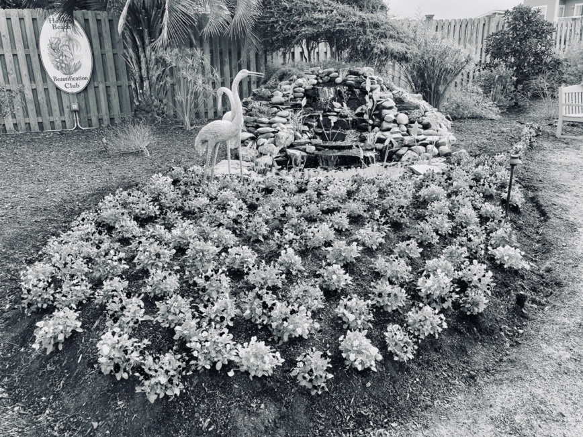
DONATIONS ARE USED IN OUR MISSION TO MAINTAIN THE PUBLIC GARDENS ON HOLDEN BEACH
Why Donate:
HBBC designs, plants, decorates and maintains the public areas of Holden Beach. This includes Padgett Garden (above), Town Hall, and the other gardens.
Each year we ask for donations to continue our work and this year donations are especially important. We are renovating Butterfly Garden and completely redesigning and replanting Town Hall. If you would like to contribute to the club’s work you may do so in two ways:
- Send a check made out to HBBC of any amount to the address below, or
- Donate online at our website: www.HoldenBeachBC.org
The Holden Beach Beautification Club is a 501C(3) Nonprofit and your donation may be tax deductible.
We are grateful for any contribution you can make!
Name: ___________________________________________________________
Mailing Address: __________________________________________________
Phone: _______________________ Email:______________________________
We list our Donors on our website. Please check here if you would like to remain anonymous.

Mail this form and your check to:
Vicki Myers, HBBC Treasurer, 301 Ocean Blvd. West, Holden Beach, NC 28462

Questions? Email us at HoldenBeachBC@gmail.com
Thank you for your support!
We are excited to announce that the 2022 Plant Sale is scheduled for April 22-23 at a new location, at Vintage Construction, 3003 Holden Beach Rd SW, near Archibald’s Deli. After being canceled the past two years we are thrilled to resume this well-loved tradition.
Find us on the web: HoldenBeachBC.org Follow us on: 

