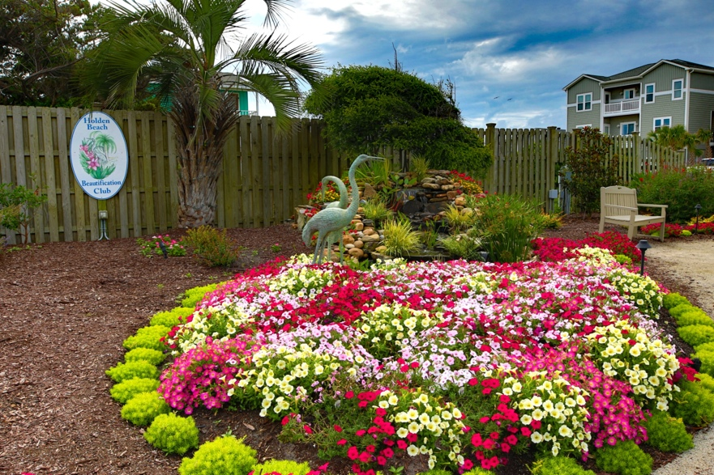
Padgett Garden – One of the Island’s gardens designed and planted by the Holden Beach Beautification Club
Holden Beach Beautification Club
2021 Sponsor Form
PROFITS ARE USED IN OUR MISSION TO MAINTAIN THE PUBLIC GARDENS ON HOLDEN BEACH AND THE NEW GARDENS ON THE MAINLAND SIDE OF THE BRIDGE.
Sponsorship Benefits:
- Company Name and Logo on HBBC website January 1- December 31, 2021.
- Includes a link from our website to your website or Facebook page!
- Advertisement at our meetings and events listing our sponsors!
- Inclusion in annual Yearbook given to all HBBC members.
Sponsorships for 2021 are $75
Name of Business: _______________________________________________
Business Mailing: ___________________ _____________________________
Contact Person: __________________________________________________
Phone: _______________________ Email:_____________________________
Website: ________________________________________________________
Please use a link to our Facebook page instead of a website
Signature: _____________________________ Date: ______________________
- Make Checks Payable to HBBC – any amount over $75 will be considered a donation.
- Mail this form and your check to Eve Venters, Sponsors Chair, PO Box 971, Clinton, NC 28329
- Email your company’s logo to vymyers@gmail.com
- Questions? Email us at HoldenBeachBC@gmail.com
Thank you for your support!
Find us on the web: HoldenBeachBC.org Follow us on: 

