17 Flowers That Look Like Something Else...
The flowers below all have two things in common: They're beautiful, and they remind the human eye of something else entirely. They are stunning works of art by nature.

Monkey Face Orchid (Affengesicht) (Dracula Simia)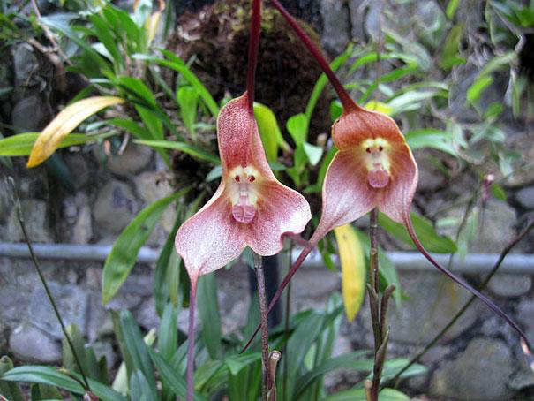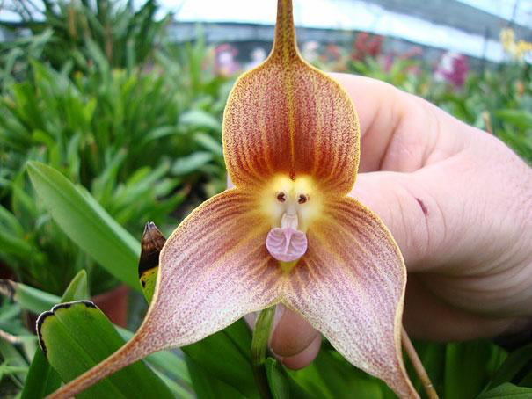

Moth Orchid (Motten) (Phalaenopsis) 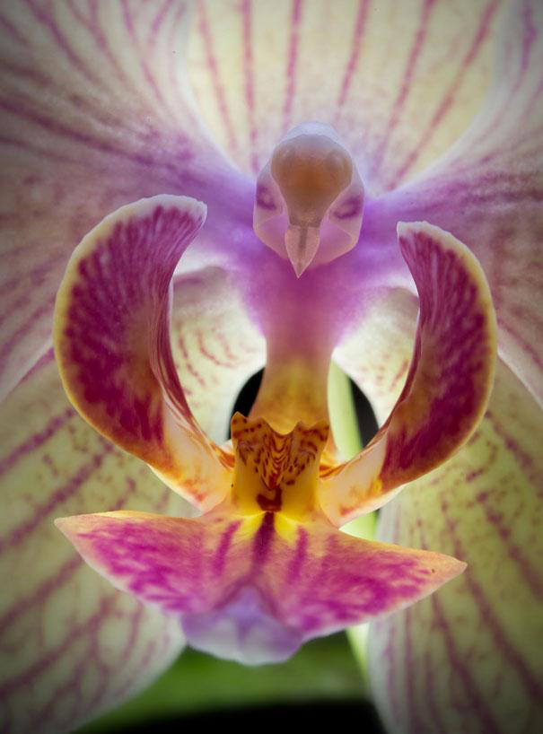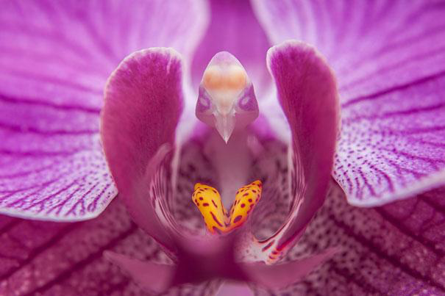 Naked Man Orchid (Nackter Mann) (Orchis Italica) 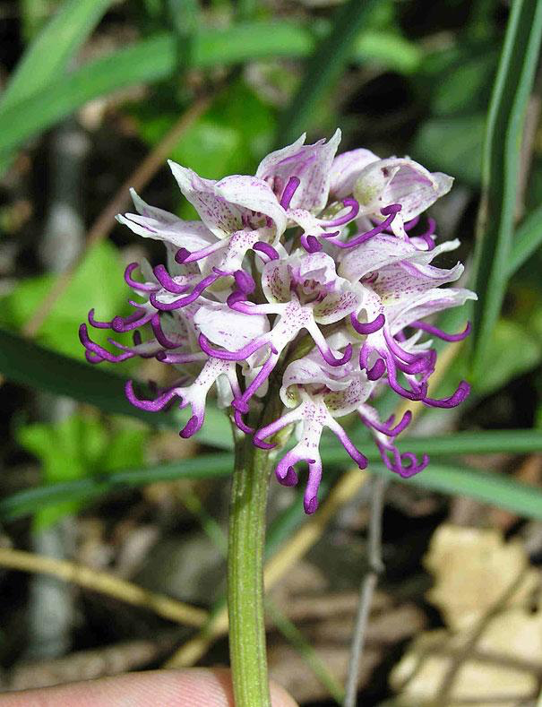 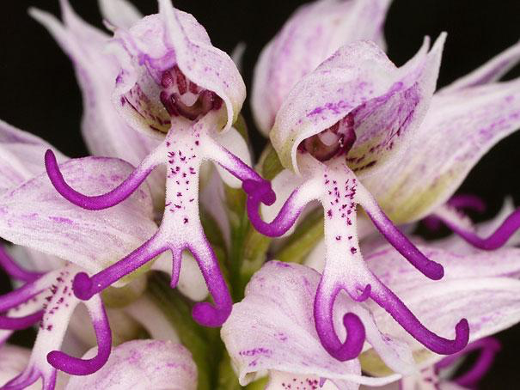

Hookerâ€™s Lips (Nuttenlippe) (Psychotria Elata)
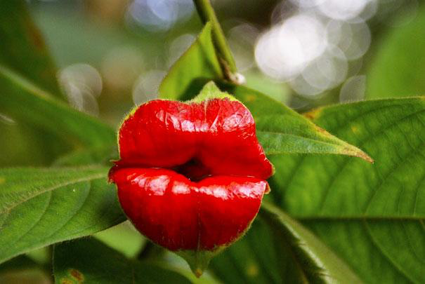
Dancing Girls (Tanzende MÃ¤dchen) (Impatiens Bequaertii)
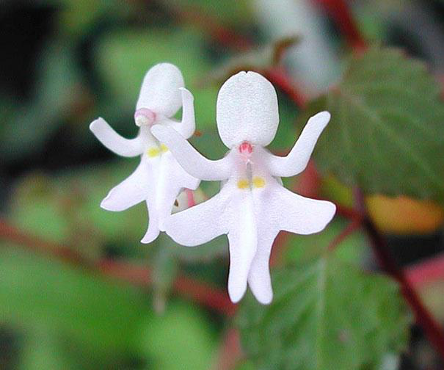
Laughing Bumble Bee Orchid (Lachende Biene) (Ophrys bomybliflora)
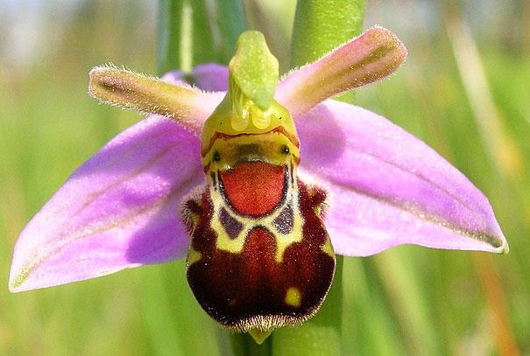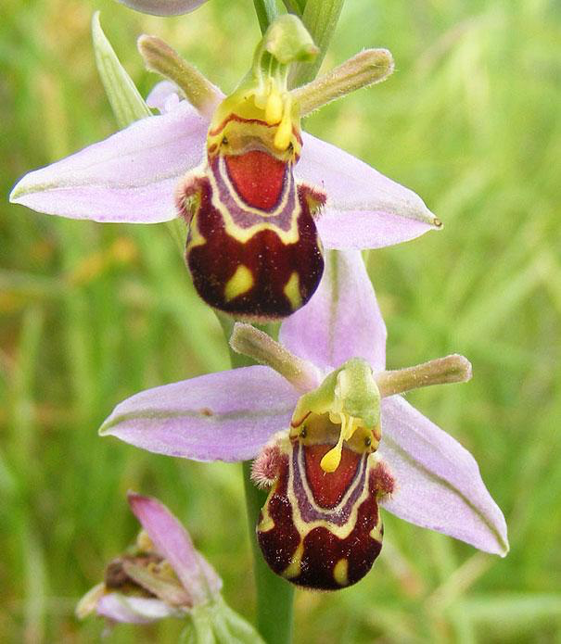
Swaddled Babies (Anguloa Uniflora)
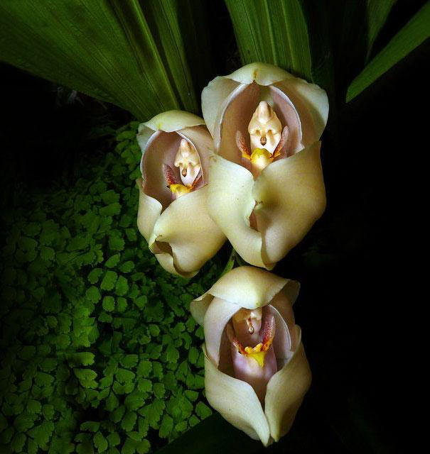
Parrot Flower (Pappagei Blume ) (Impatiens Psittacina)
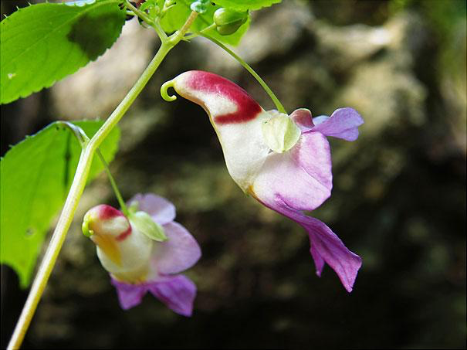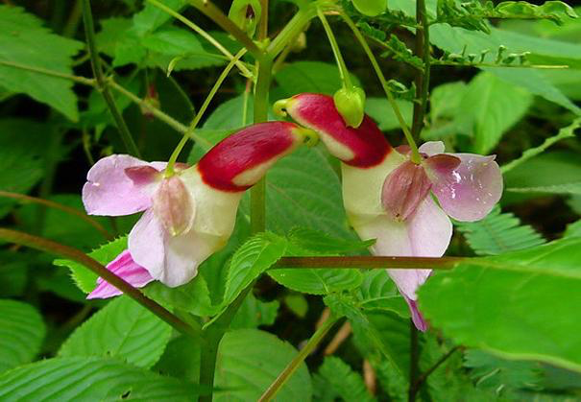
Snap Dragon Seed Pod (Antirrhinum)
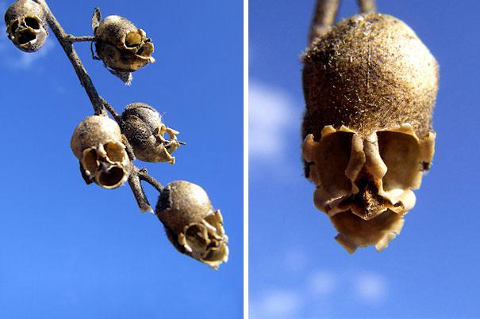
Flying Duck Orchid (Fliegende Ente) (Caleana Major)
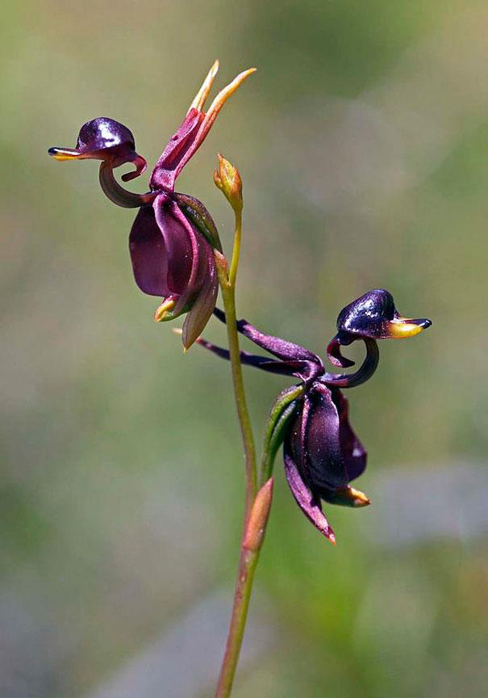
An orchid that looks remarkably like a tiger (Tiger Gesicht)
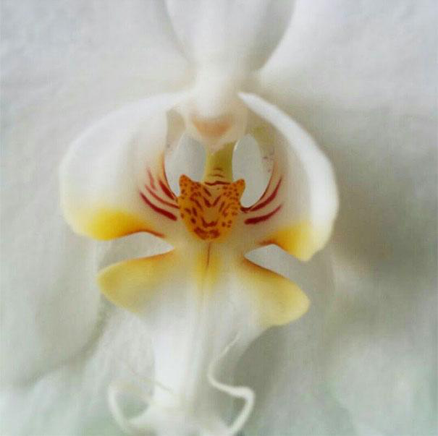
Happy Alien (Calceolaria Uniflora)
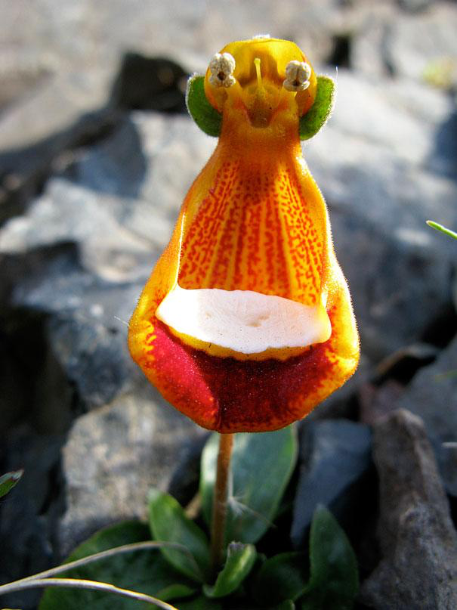
And his friends... und seine Freunde

Angel Orchid (Engel) (Habenaria Grandifloriformis)
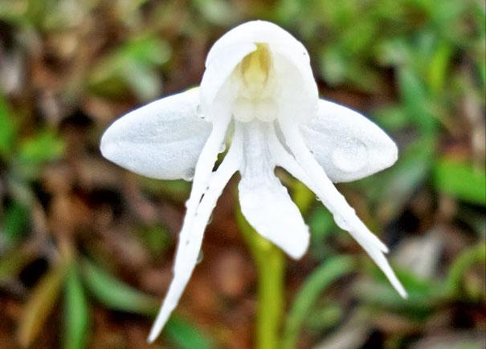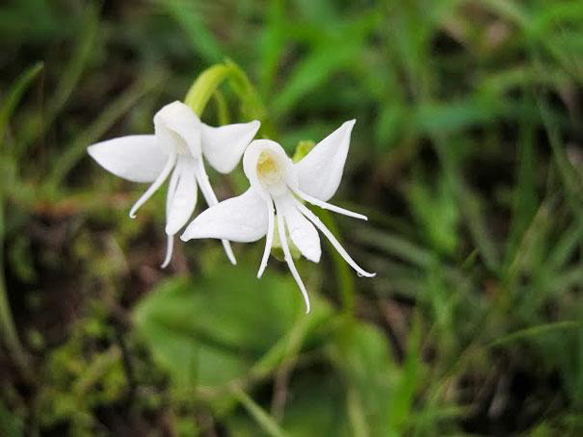
Dove Orchid Or Holy Ghost Orchid (Peristeria Elata) (Taube oder Heigliger Geist)
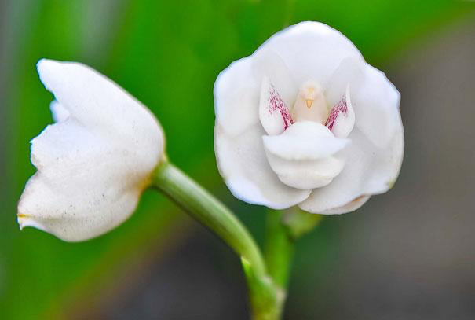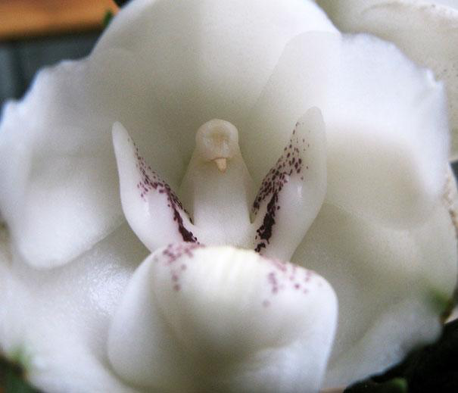

White Egret Orchid (Habenaria Radiata) (Silberreiher)
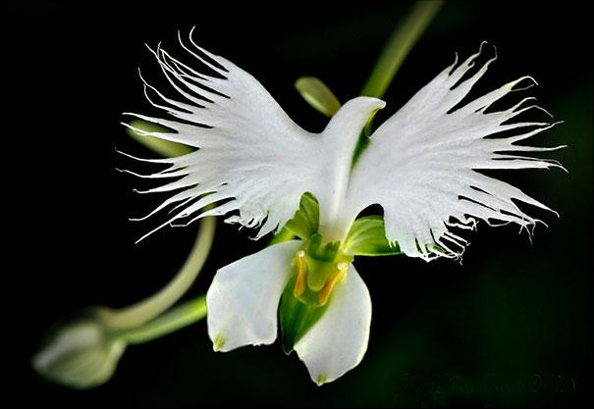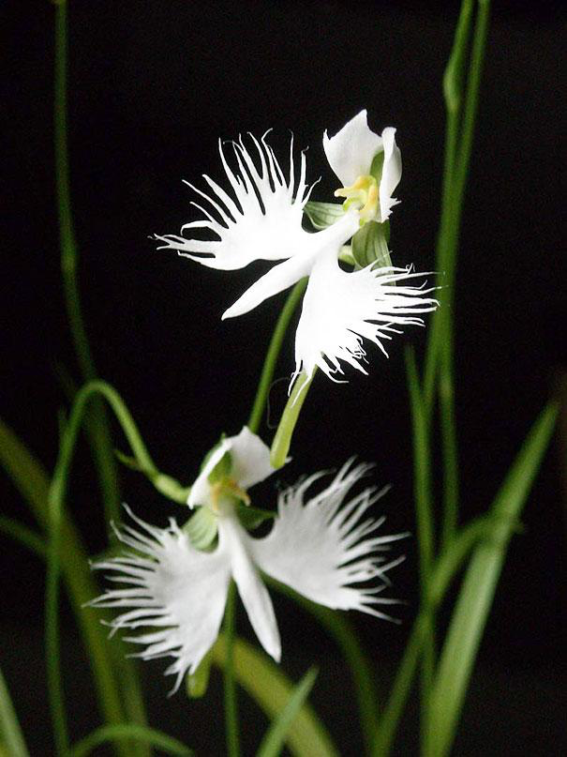
The Darth Vader (Aristolochia Salvadorensis)
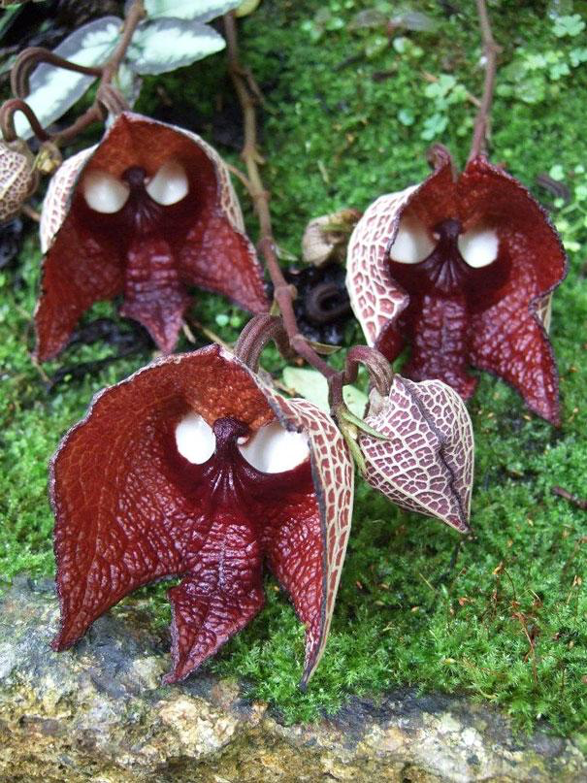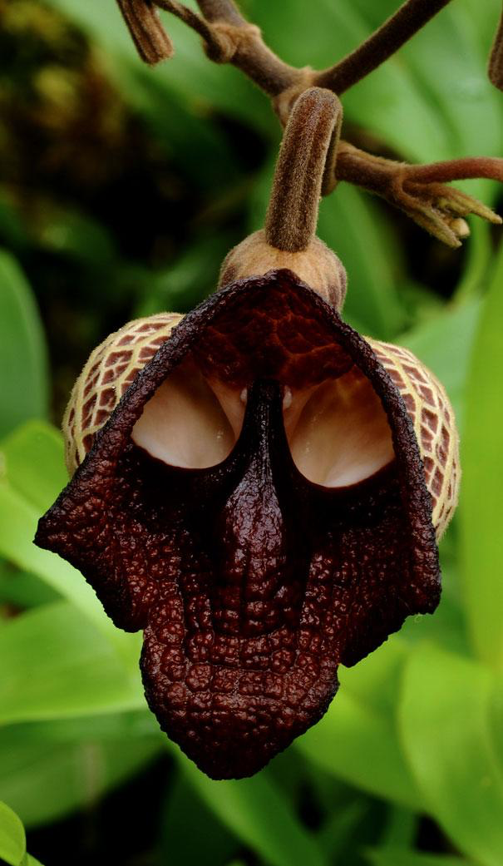
An Orchid That Looks Like A Ballerina 